**Laurencin, Marie (1883-1956)**

[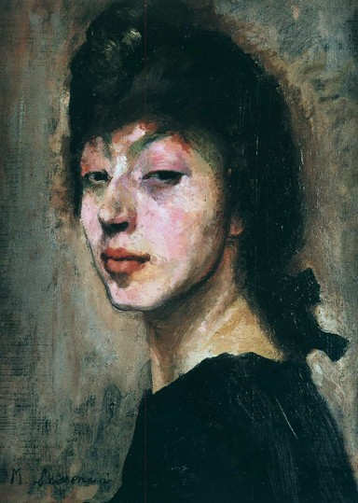](http://idata.over-blog.com/0/41/46/90/05_12_12/Marie-Laurencin-Autoportrait-Circa-1905.jpg)  
***Autoportrait***, c. 1905

(http://ptutoy.over-blog.net/article-autoportrait-de-femme-peintre-et-tete-pe-115744611.html)

SUMMARY

Marie Laurencin was a painter, etcher, lithographer, illustrator, and decorative artist of the Parisian avant-garde in the early twentieth century. She is most widely known for her affiliations with artistic and literary figures of the Cubist and Dadaist movements. Her paintings are noted for their soft portrayal of feminine subjects, including a series of self-portraits.

MAIN ENTRY

Marie Laurencin, an artist associated with several avant-garde movements, was born in Paris on October 31, 1883 to Pauline Laurencin. She endured an idiosyncratic childhood, living alone with her mother at 51, boulevard de la Chapelle, and without knowing her father’s identity. During her youth, however, a man named Alfred Toulet would occasionally come for what seemed to Laurencin to be inexplicable and bothersome visits. Only after his death did she learn the man was her father. Although she had been drawing since her childhood, her decision to become an artist began as a compromise with her mother’s aspirations for her to become a secondary school teacher. Together they decided she would study porcelain painting and, after studying at the Lycée Lamartine, she enrolled at the Ecole de Sèvres and then the Académie Humbert.

At the Académie Humbert, Laurencin met Francis Picabia and Georges Braque, who would later introduce her to Pablo Picasso. In 1907, Picasso introduced her to Guillaume Apollinaire, famously telling his friend that he had found the perfect “fiancée” for him. Indeed, Laurencin and Apollinaire fast became lovers and the intense and passionate relationship they shared lasted until the end of 1912. Apollinaire wrote endless poems about her, and it is often noted that in an early review of her work he commented, “She is a little sun; she is me in feminine form!” (qtd. in Hyland and McPherson). Laurencin, a poet as well, would occasionally publish her poems using the nom de plume “Louise Lalanne,” a pseudonym also used by Apollinaire. In 1942, under her own name, Laurencin published her personal journals as *Le carnet des nuits*.

During the nearly six years of her affair with Apollinaire, Laurencin became part of Picasso’s artistic circle. Through him, she met artistic and literary giants such as Juan Gris, Max Jacob, André Salmon, Jean Cocteau, Fernande Olivier, Amedeo Modigliani, and Gertrude Stein, among others. Though by most accounts Laurencin was either adored or despised, her presence amid the Bateau-Lavoir crowd is confirmed by her attendance at the historic dinner banquet organized by Picasso in honor of the painter Henri Rousseau. This dinner party inspired Laurencin to paint *Group of Artists* (eventually known as *Les Invités*), which included portraits of Picasso, Fernande Olivier, and Guillaume Apollinaire, with Laurencin standing behind. The painting is notable for two primary reasons: it her first professional sale as an artist, and it was purchased by Gertrude Stein. The following year Laurencin produced an expanded version of this painting, *Réunion à la campagne* (or, *Apollinaire et ses amis*), featuring Apollinaire at the center, surrounded by Picasso, Marguerite Gillot, Maurice Cremnitz and Laurencin as well as others.

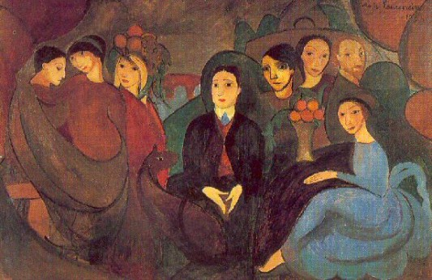

***Réunion à la campagne*** (or, ***Apollinaire et ses amis***), 1909 (http://dormirajamais.org/marie/)

In June 1914, on the eve of the Great War, Laurencin married Otto von Waëtjen, another artist and fellow student from the Académie Humbert. Shortly after their marriage they were forced to relocate to Spain, where they remained until the end of the war. Although away from Paris Laurencin felt deeply exiled, the couple again relocated to Düsseldorf, Germany, where they lived for another year. In 1920, Laurencin filed for divorce and finally returned to Paris, alone.

Laurencin is associated with various avant-garde art movements, from Cubism to Surrealism and Dadaism. Most of the accounts of these associations are merely social, as her work itself does not reflect the credos of these movements. Though she maintained acquaintances and personal relationships with key figures in the various artistic movements, occasionally writing for their journals and even co-editing the Dadaist magazine *391*, her work retains her unique style and strongly resists the labels of any of her specific avant-garde associations.

Laurencin’s paintings are often characterized as feminine, sometimes feminist, renditions of female subjects in soft colors—she was widely known for a color palette that consisted of a peculiar soft pink, pale blues and greens, and plenty of white. In addition to a large number of self-portraits as well as portraits of other women, Laurencin is known for her decorative arts. She earned popular and critical praise for her work originating all the costumes and set designs for the Ballets Russes’s production of *Les* *Biches* in 1924.

|  |  |
| --- | --- |
|  |  |

***Portrait de mademoiselle Chanel***, 1923

(http://www.musee-orangerie.fr/pages/page_id19181_u1l2.htm)

While her work was widely renowned during her lifetime, Laurencin had a popular reputation as a good artist but not a great one. In fact, Coco Chanel once commissioned Laurencin to paint her portrait—but famously turned down the final piece. However, that Laurencin was wildly famous is indisputable: in 1930, an article in *Vu* magazine listed her as one of “The Three Most Famous Women in France” (qtd. in Elliott).

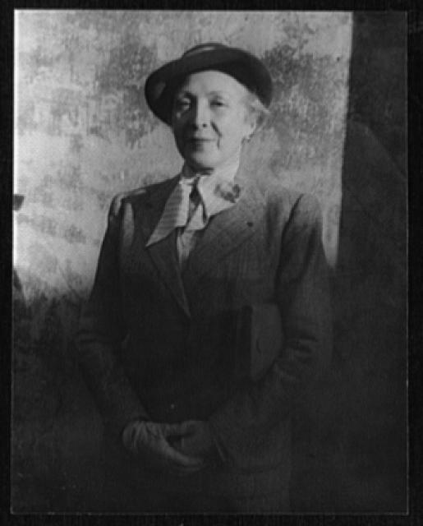

Marie Laurencin, photographed by Carl Van Vechten in1949

(http://www.loc.gov/pictures/item/2004663187/)

Laurencin died in Paris in 1956. Since her death, Laurencin’s work has been revived and acclaimed in several pockets of enthusiastic scholarship. In 1983, the Musée Marie Laurencin opened in Japan in commemoration of the 100th anniversary of her birth. Musée Marmottan Monet in Paris hosted the most recent retrospective of her work in 2013.

Beginning with her first critics in the 1910’s until the present, there is a tendency to categorize her work as either impossibly feminine or radically feminist. Some scholars of more recent decades have come to understand her as a feminist artist who dared to remain uninfluenced by the dominant male artists of her period; some emphasize her bisexuality. Bridget Elliott, in her piece ‘The “Strength of the Weak” as Portrayed by Marie Laurencin’ works to balance this perception by arguing that the nature of the avant-garde movement allowed Laurencin and others the space to maneuver and manipulate the current artist trends.

**List of Selected Works:**

1908 *Pablo Picasso*

*Group of Artists* (*Les Invités*)

1909 *Réunion à la campagne* (or, *Apollinaire et ses amis*)

1910-11 *Les jeunes filles*

1915 *Deux filles*

1922 *Portrait de Mm. Nichole Groult*

1923 *Portrait de Mademoiselle Chanel*

1925 *L’Italienne*

*L’Ambassadrice*

1936 *The First Renault Car 1898* (lithograph)

**References and Further Reading:**

Elliott, Bridget. (2005) “The Strength of the Weak’ as Portrayed by Marie Laurencin” in *Reclaiming Female Agency*, Norma Broude and Mary D. Garrard (eds.), Los Angeles: U of California Press.

Gere, Charlotte. (1977) *Marie Laurencin*, London: Academie Editions.

Hyland, Douglas K. S. & McPherson, Heather. (1989) *Marie Laurencin: Artist and Muse*, Settle: U of Washington Press.

Kahn, Elizabeth Louise. (2003) *Marie Laurencin:* Une Femme Inadaptée *in Feminist Histories of Art*, Burlington: Ashgate.